FULL STACK WEB DEVELOPMENT
LABORATORY RECORD — EXPERIMENT 03

1. BASIC INFORMATION
Experiment No. | 03
Date | 25/08/2026
Title | Student Marks Analyzer using JavaScript Arrays and Functions
Application | Student Marks Analyzer
Course Outcome | CO1

2. AIM
To develop a JavaScript-based Student Marks Analyzer that uses arrays and functions to calculate the total, average, highest mark, lowest mark, and pass/fail result.

3. OBJECTIVE
- Store marks of five subjects using a JavaScript array.
- Use functions to perform separate calculations on the marks.
- Calculate total and average marks.
- Find the highest and lowest marks.
- Determine whether the student has passed or failed.
- Display the calculated results dynamically using DOM manipulation.

4. THEORY
An array in JavaScript is a collection used to store multiple values in a single variable. In this experiment, the marks of five subjects are stored in an array.
A function is a reusable block of code designed to perform a particular task. Separate functions are used to calculate the total, average, highest mark, lowest mark, and pass/fail result.
The program also uses DOM methods to read the marks entered by the user and display the calculated results dynamically on the webpage.

5. SOFTWARE / APPARATUS USED
- Computer / Laptop
- Minimum 4 GB RAM
- Windows 10 / 11
- Visual Studio Code
- Google Chrome / Microsoft Edge
- HTML5, CSS3 and JavaScript

6. PROGRAM STRUCTURE
Experiment-03-JavaScript-Arrays-Functions
├── screenshots
│ └── output.png
└── src
├── index.html
├── app.js
└── style.css

7. ALGORITHM / PROCEDURE
- Create an HTML webpage with five input fields for subject marks.
- Create an Analyze Marks button.
- Read the values entered by the user.
- Store the five marks in a JavaScript array.
- Create a function to calculate the total marks.
- Create a function to calculate the average.
- Create functions to find the highest and lowest marks.
- Create a function to determine whether the student has passed or failed.
- Call the required functions when the button is clicked.
- Display the marks and calculated results dynamically on the webpage.
- Apply CSS styling to make the webpage presentable.
- Test the program using different sets of marks.

8. SOURCE CODE

HTML — index.html
<!DOCTYPE html>
<html lang="en">
<head>
<meta charset="UTF-8">
<meta name="viewport" content="width=device-width, initial-scale=1.0">
<title>Student Marks Analyzer</title>
<link rel="stylesheet" href="style.css">
</head>
<body>
<div class="container">
<h1>Student Marks Analyzer</h1>
<p>Enter marks for five subjects:</p>
<div class="inputs">
<input type="number" id="mark1" placeholder="Subject 1">
<input type="number" id="mark2" placeholder="Subject 2">
<input type="number" id="mark3" placeholder="Subject 3">
<input type="number" id="mark4" placeholder="Subject 4">
<input type="number" id="mark5" placeholder="Subject 5">
</div>
<button id="analyzeBtn">Analyze Marks</button>
<div id="result"></div>
</div>
<script src="app.js"></script>
</body>
</html>

JavaScript — app.js
function calculateTotal(marks) {
let total = 0;
for (let mark of marks) {
total += mark;
}
return total;
}
function calculateAverage(marks) {
let total = calculateTotal(marks);
return total / marks.length;
}
function findHighest(marks) {
return Math.max(...marks);
}
function findLowest(marks) {
return Math.min(...marks);
}
function checkResult(marks) {
for (let mark of marks) {
if (mark < 40) {
return "Fail";
}
}
return "Pass";
}
const analyzeButton = document.getElementById("analyzeBtn");
analyzeButton.addEventListener("click", function () {
const marks = [
Number(document.getElementById("mark1").value),
Number(document.getElementById("mark2").value),
Number(document.getElementById("mark3").value),
Number(document.getElementById("mark4").value),
Number(document.getElementById("mark5").value)
];
const total = calculateTotal(marks);
const average = calculateAverage(marks);
const highest = findHighest(marks);
const lowest = findLowest(marks);
const result = checkResult(marks);
document.getElementById("result").innerHTML = `
<h2>Result</h2>
<p><strong>Marks:</strong> ${marks.join(", ")}</p>
<p><strong>Total:</strong> ${total}</p>
<p><strong>Average:</strong> ${average.toFixed(2)}</p>
<p><strong>Highest Mark:</strong> ${highest}</p>
<p><strong>Lowest Mark:</strong> ${lowest}</p>
<p><strong>Result:</strong> ${result}</p>
`;
});

CSS — style.css
body {
font-family: Arial, sans-serif;
background: linear-gradient(135deg, #e3f2fd, #f5f5f5);
margin: 0;
padding: 40px;
}
.container {
max-width: 650px;
margin: auto;
background-color: white;
padding: 30px;
border-radius: 12px;
box-shadow: 0 4px 15px rgba(0, 0, 0, 0.15);
}
.inputs {
display: grid;
grid-template-columns: 1fr 1fr;
gap: 12px;
margin: 20px 0;
}
input {
padding: 12px;
border: 1px solid #aaa;
border-radius: 6px;
}
button {
display: block;
margin: 20px auto;
padding: 12px 25px;
border: none;
border-radius: 6px;
cursor: pointer;
}
#result {
margin-top: 25px;
padding: 20px;
border-radius: 8px;
background-color: #f5f5f5;
}

9. CODE EXPLANATION
Code / Concept | Purpose
Array | Stores the five subject marks together.
calculateTotal() | Adds all marks and returns the total.
calculateAverage() | Calculates the average using total divided by number of marks.
findHighest() | Uses Math.max() to find the highest mark.
findLowest() | Uses Math.min() to find the lowest mark.
checkResult() | Checks whether every mark is at least 40.
Number() | Converts input values from strings to numbers.
for...of | Iterates through the values of the marks array.
marks.length | Returns the number of elements in the array.
toFixed(2) | Displays the average with two decimal places.
innerHTML | Displays the calculated result dynamically on the webpage.

10. TEST DATA AND SAMPLE CALCULATION
Input Marks | Calculation | Expected Result
70, 80, 85, 90, 100 | Total = 425; Average = 425 / 5 | Pass
40, 50, 60, 70, 80 | Total = 300; Average = 60.00 | Pass
30, 70, 80, 90, 100 | One mark is below 40 | Fail
For the actual output shown in this record, the entered marks are 70, 80, 85, 90, and 100. Therefore, Total = 425, Average = 85.00, Highest Mark = 100, Lowest Mark = 70, and Result = Pass.

11. COMPILATION / EXECUTION STEPS
- Open the Experiment-03-JavaScript-Arrays-Functions folder in Visual Studio Code.
- Ensure index.html, app.js, and style.css are present inside the src folder.
- Open index.html using Google Chrome or Microsoft Edge.
- Enter marks for all five subjects.
- Click Analyze Marks.
- Observe the total, average, highest mark, lowest mark, and pass/fail result.
- Test the application with different mark values.

12. OUTPUT
The following is the actual browser output captured after entering marks for five subjects and clicking the Analyze Marks button.
Figure 1: Student Marks Analyzer — Actual Output
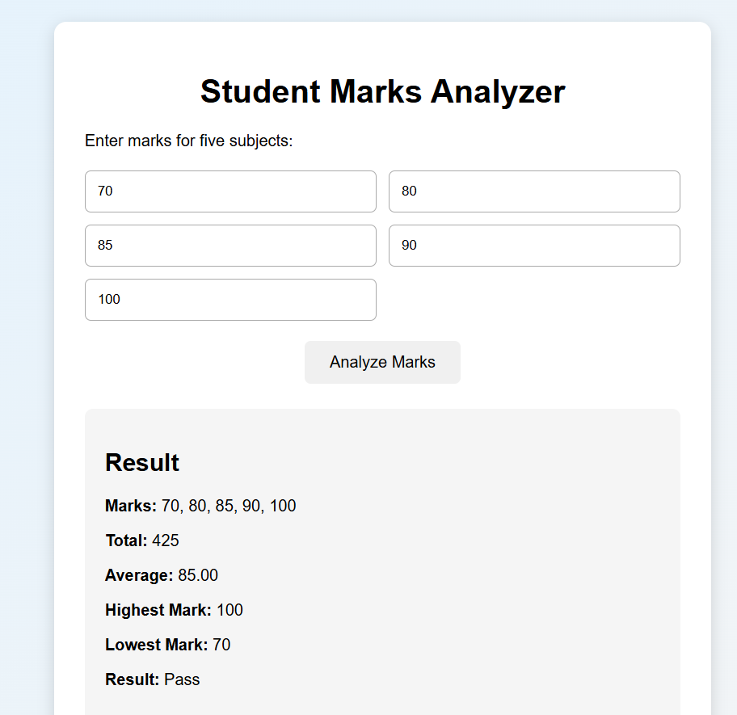

13. RESULT ANALYSIS
The program successfully accepted five subject marks and stored them in a JavaScript array. The defined functions correctly calculated the total, average, highest mark, lowest mark, and pass/fail status. The results were displayed dynamically on the webpage.

14. RESULT / CONCLUSION
The Student Marks Analyzer was successfully implemented using JavaScript arrays and functions. The program demonstrated the use of arrays for storing multiple values and functions for performing separate operations on the data.

15. PRECAUTIONS
- Enter valid numerical marks for all subjects.
- Marks should be within the range of 0 to 100.
- Ensure that the JavaScript file is correctly linked to the HTML file.
- Ensure that the IDs in HTML match the IDs used in JavaScript.
- Save all files before executing the program.
- Verify the output with different sets of input values.

16. VIVA-VOCE QUESTIONS
1. What is an array in JavaScript?
An array is a data structure used to store multiple values in a single variable.
2. Why did you use an array in this program?
It allows the marks of all five subjects to be stored together and processed efficiently.
3. What is a function?
A function is a reusable block of code that performs a specific task.
4. Why did you create separate functions?
Separate functions make the program modular, readable, reusable, and easier to maintain.
5. What does marks.length return?
It returns the number of elements present in the marks array. Here it returns 5.
6. What does Math.max(...marks) do?
It returns the highest mark in the array.
7. What does Math.min(...marks) do?
It returns the lowest mark in the array.
8. Why is Number() used?
HTML input values are obtained as strings, so Number() converts them into numbers for arithmetic operations.
9. What does toFixed(2) do?
It formats the average to two digits after the decimal point.
10. What is the purpose of for...of?
It iterates through the values of an array.

